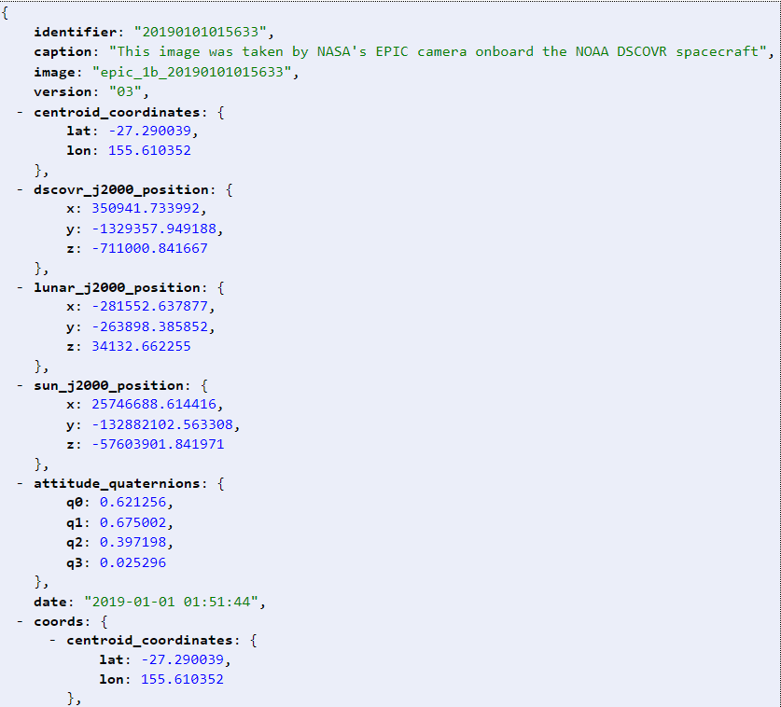

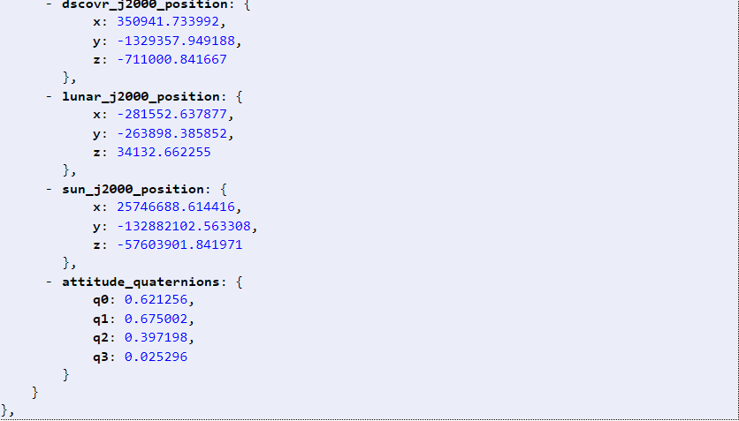

Testes que poderiam ser realizados na API

1 – Verificar se a API está retornando o status 200.

2 – Verificar se a API retorna status 403 ao acessar de forma invalida.

3 – Realizar o teste de contrato para confirmar que todas as informações que estão sendo fornecidas são informações validas.

Schema: {

Identifier: Joi.number().integer.required()

Caption: Joi.string()

Image: Joi.string().required()

Version: Joi.number().double()

Centroid_coordinates: {

Lat: Joi.number().double().required()

Long: Joi.number().double().required() }

Dscovr_j2000_position: {

x: Joi.number().double().required()

y: Joi.number().double().required()

z: Joi.number().double().required() }

Lunar_j2000_position: {

x: Joi.number().double().required()

y: Joi.number().double().required()

z: Joi.number().double().required() }

Sun_j2000_position: {

x: Joi.number().double().required()

y: Joi.number().double().required()

z: Joi.number().double().required() }

Attitude_quaternions: {

q0: Joi.number().double().positive()

q1: Joi.number().double().positive()

q2: Joi.number().double().positive()

q3: Joi.number().double().positive()

}

date: Joi.date().iso().required()